  - Corna Virus Statics

  - Document History
Date | Version | Role | Name | Comment
10/9/2025 | 1.0 | Business Analyst |  | Created initial draft
Contents
I. Introduction 3
1.1. Purpose 3
1.2. Objectives 3
1.3. Process key contacts 3
1.4. Minimum prerequisites for the automation 4
II. As-is process description 4
2.1. Process overview 4
2.2. Applications used 5
2.3. As-is process map 5
2.3.1. High-level process map 5
2.3.2. Detailed level process map 6
2.4. Detailed as-is process actions 6
III. To-be process description 6
3.1. Detailed to-be process map 6
3.2. Input/Output data description 6
3.3. Exceptions Handling 7
3.4.1. Known business exceptions 7
3.4.2. Unknown business exceptions 7
3.4. Applications errors and exceptions handling 7
3.5.1. Known applications errors and exceptions 7
3.5.2. Unknown applications errors and exceptions 8
3.5. Reporting 8
3.6. In scope for automation 8
3.7. Out of scope for automation 8
3.8. Change/Improvement details 9
IV. Other 9
4.1. Additional sources of process documentation 9
4.2. Change requests 9
4.3. Document approval 10

Introduction

Purpose
The purpose of designing this process as a state diagram is to provide a high-level representation of how the system transitions through different operational states when generating and storing random weather data .

Objectives
The objective of the current COVID-19 statistics extraction process is to ensure that users can seamlessly retrieve accurate pandemic-related data for a selected country, format it according to business requirements, and store it efficiently in a structured file. The process aims to provide standardized reporting by automating web data retrieval, formatting, and file saving, thereby reducing reliance on manual operations .
Objectives | Benefits
Improve overall reliability and performance | Consistent extraction of COVID-19 statistics without manual errors
Reduce human error | Eliminates mistakes in searching, copying, formatting, or saving outputs
Speed up data retrieval cycle | Faster extraction and file generation compared to manual web search and recording
Ensure accuracy and consistency in data | Automated handling maintains standardized output formatting
Enhance compliance with defined rules | Ensures mandatory statistics (cases, deaths, recovered) are always included
Increase scalability | Ability to handle multiple country queries in sequence without extra effort
Reduce operational effort | Minimizes dependency on repeated manual tasks like web navigation and data entry
Improve exception handling and monitoring | Automated error logging and structured retry mechanisms ensure stability

Process key contacts
The specifications document includes concise and complete requirements of the business process, and it is built based on the inputs provided by the process Subject Matter Expert (SME)/ Process Owner.
The Process Owner is expected to review it and provide signoff for accuracy and completion of the steps, context, impact, and complete set of process exceptions.
The names have to be included in the table below.

Role | Name | Contact Details
Business Analyst | Youssef Kamel | Youssefmk1214@gmail.com
Process SME / Process reviewer | Mohamed Mesbah | Mohamed.mesbah@rackist.com

Minimum prerequisites for the automation
- Filled-in Process Definition Document
- Test Data to support development.
- User access and user accounts creations (Access to the weather generator web application, including any licenses, permissions, and restrictions for robots. Credentials (user ID and password) required to log )
- Storage Location (Defined local or network folder path where generated weather data files (e.g., text outputs) will be stored).

Business Rules
BR# | Requirement | Additional Information
BR001 | When entering the country name, only valid country names should be accepted | Invalid or misspelled names should trigger an error and stop further processing
BR002 | When extracting statistics, ensure all three values (cases, deaths, recovered) are captured | If any field is missing, process should not continue and must raise a business exception
BR003 | When opening Notepad, the font must be set to Times New Roman, Bold, Size 28 | Ensures standardized formatting of all output reports
BR004 | When saving the output file, a valid path and filename must be provided | Invalid paths or missing names should prompt user to re-enter before saving
BR005 | At process completion, both the browser and Notepad must be closed | Prevents unnecessary system resource usage and duplicate process conflicts

As-is process description

Process overview
The process begins with the user providing a country name as input. The system then launches a browser, searches for the specified country’s COVID-19 statistics, and extracts the key data points: cases, deaths, and recovered. Once extracted, the process opens Notepad, applies the required formatting, and writes the results into a structured file. Finally, the file is saved to a specified location, and all applications are closed to complete the process .
Item | Description/Answer
Process Full Name | COVID-19 Statistics Extraction and Reporting
Process Area | Data Collection / Public Health Analytics
Department | Research & Analytics / Reporting
Short Description (operation, activity, outcome) | The process opens a browser, searches for a country’s COVID-19 statistics, extracts key data points (cases, deaths, recovered), and stores the results in a formatted text file
Role(s) required in applications to perform the process | Analyst
Process schedule and frequency | On-demand
Number of items per month | ~600 country data extraction requests (average)
Average handling time per item | 3 minutes
Process Restrictions | Requires internet access and availability of the weather generator web application..
Peak Period (s) | During government reporting cycles or pandemic updates
Peak Volume Approximate increase | Up to 30% increase in requests
Total # of FTEs supporting this activity | 1 (currently handled manually by user)
Expected Volume increase during next periods | Moderate increase depending on reporting demand
Input data description | Country name (user-provided), File path for saving output
Output Data description | COVID-19 data (cases, deaths, recovered), stored in formatted text file
ROI | Saves ~30+ hours per month by reducing manual effort, improving accuracy, and standardizing reporting

Applications used
The table includes a comprehensive list of all the applications that are used as part of the process to be automated to perform the given actions in the flow.

Application Name | Details (Version, Language, Environment/ Access method)
Any Browser SW | Used To Search Corna Virus Statics
Notepad Txt Editor | Used To Save Extracted Data

As-is process map

High-level process map
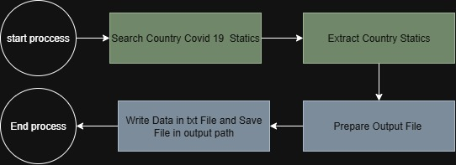

Detailed level process map
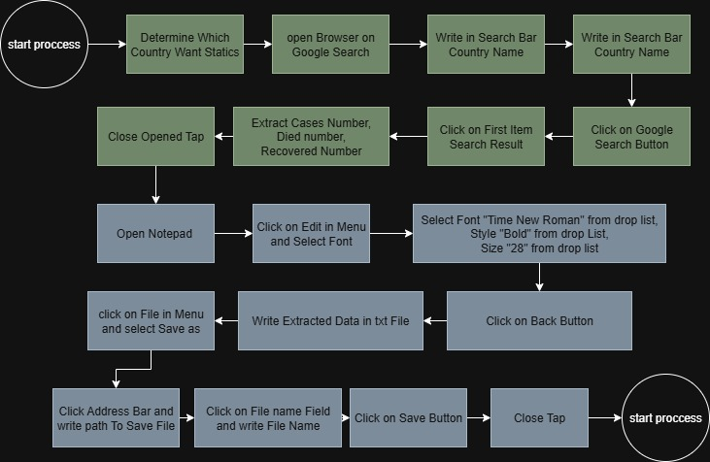

Detailed as-is process actions
# | Input | Description | Details | Exception Handling | Output
1 | - | Open Browser on Google Search |  | AE01 | 
2 | Country Name | Type Into Search bar “Country Name coronavirus worldometer” | 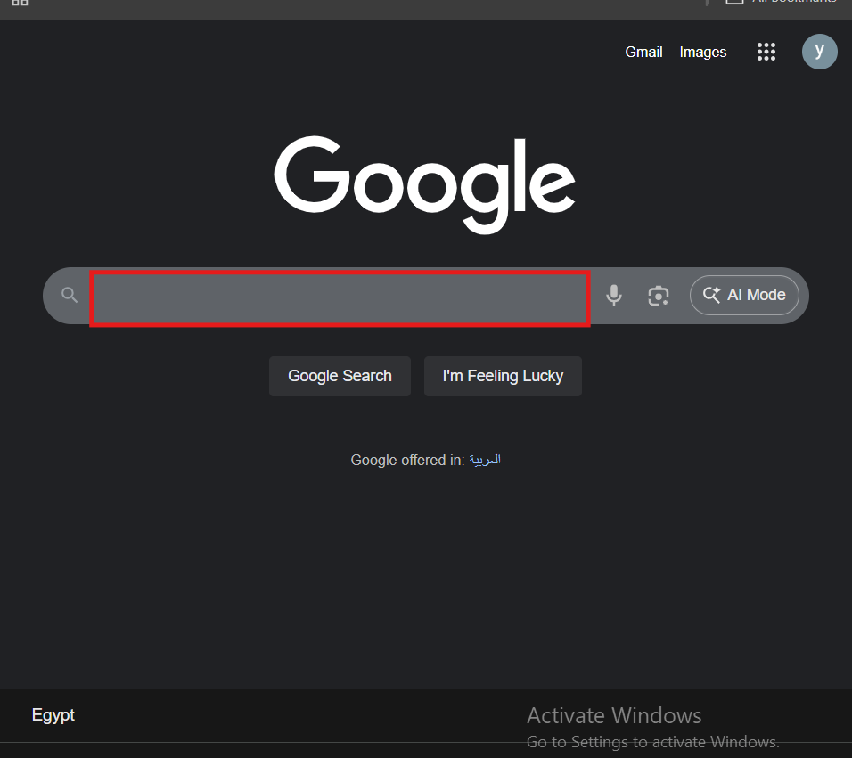 | BE02 | 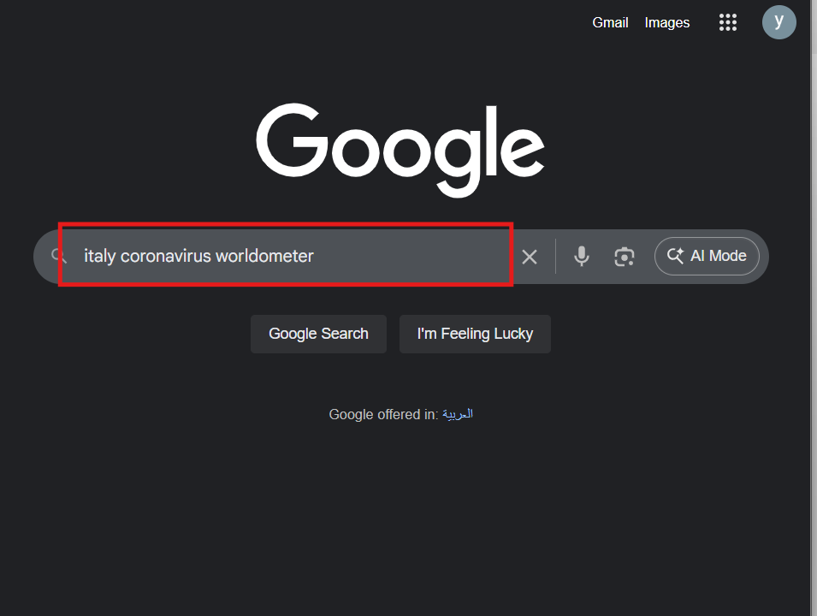
3 |  | Click on Google Search Button | 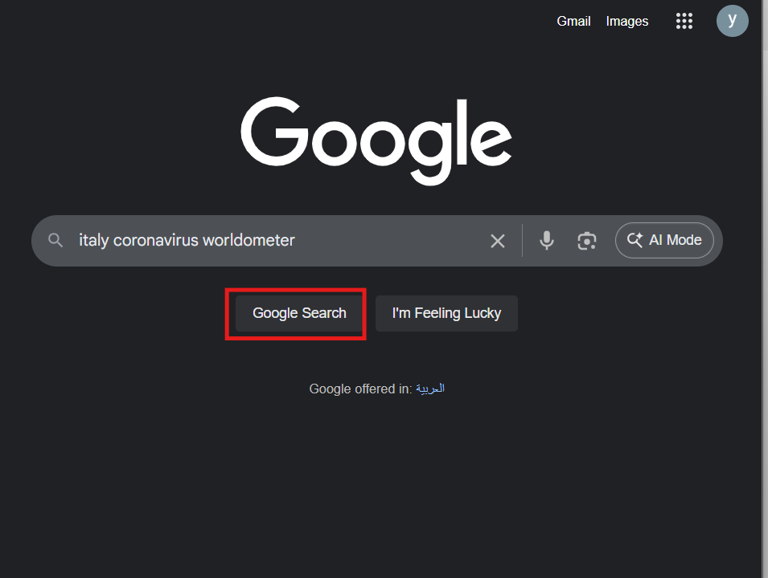 |  | 
4 |  | Click on First Item on Search Result | 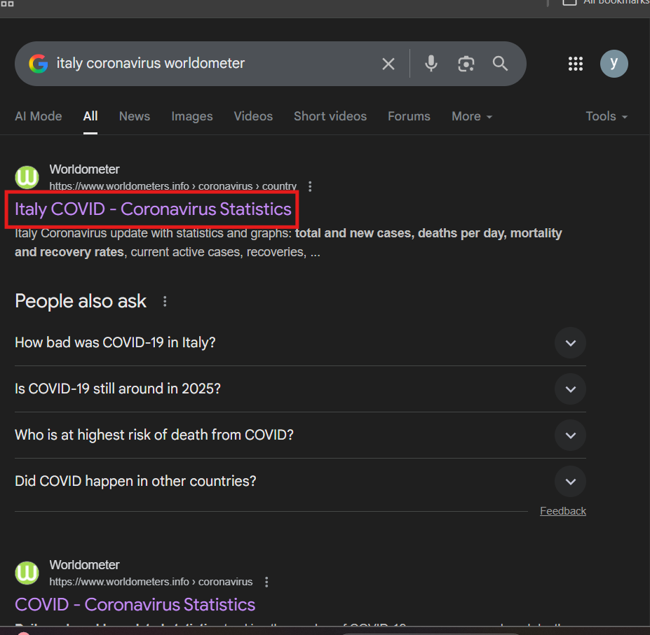 | AE02 | 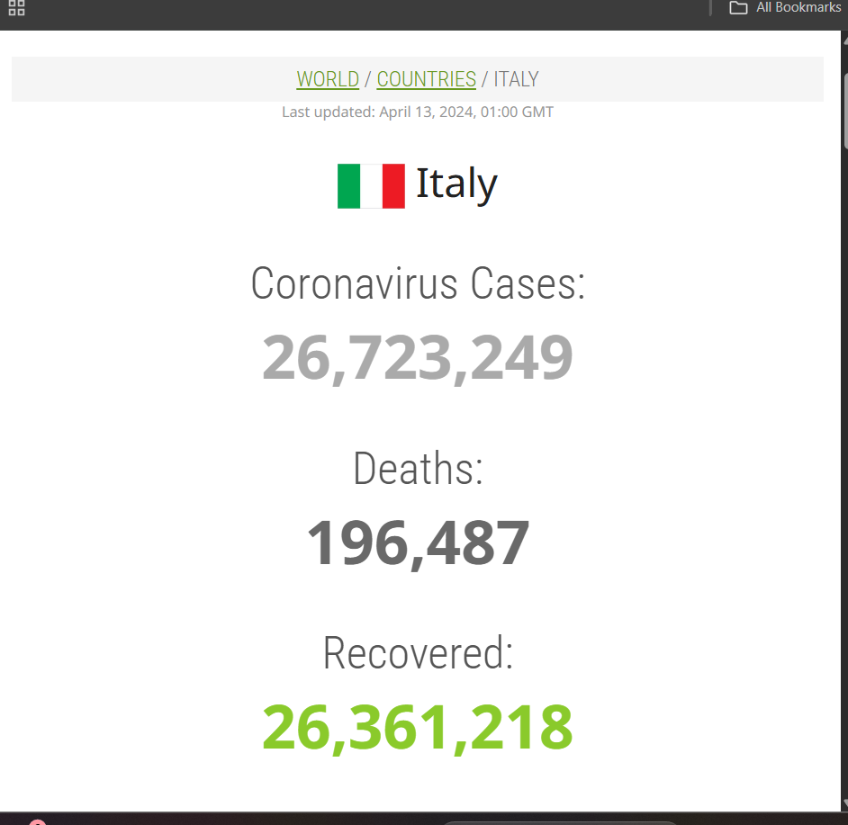
5 |  | Extract Cases Number,  Died number,  Recovered Number | 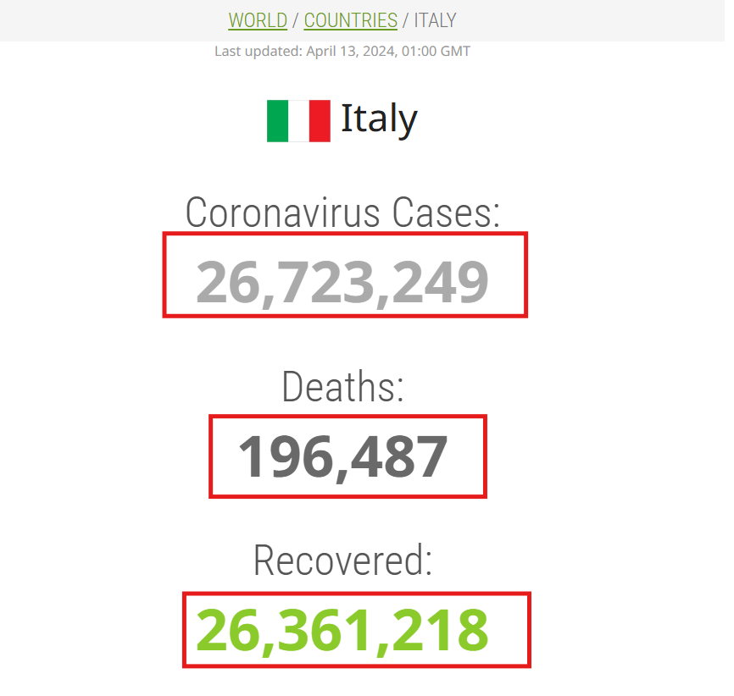 | BE01
6 |  | Close opened Google Chrome Tap
7 |  | Open Notepad on new untitled tap |  | AE03
8 |  | Click on Edit in Menu and Select Font | 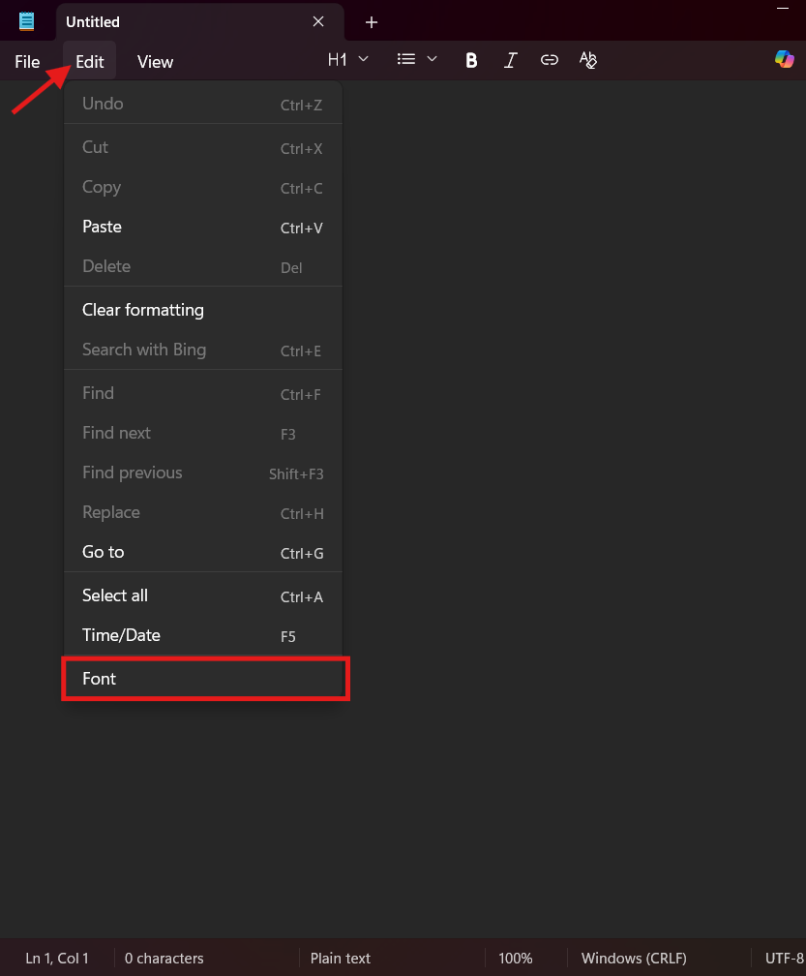 |  | 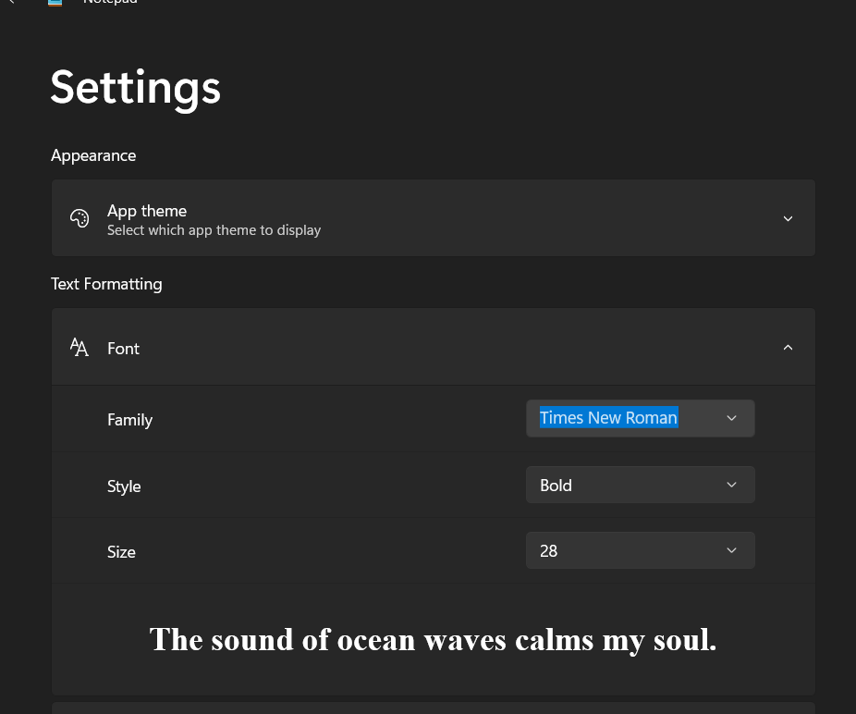
9 |  | Select Font "Time New Roman" from drop list,  Style "Bold" from drop List,  Size "28" from drop list | 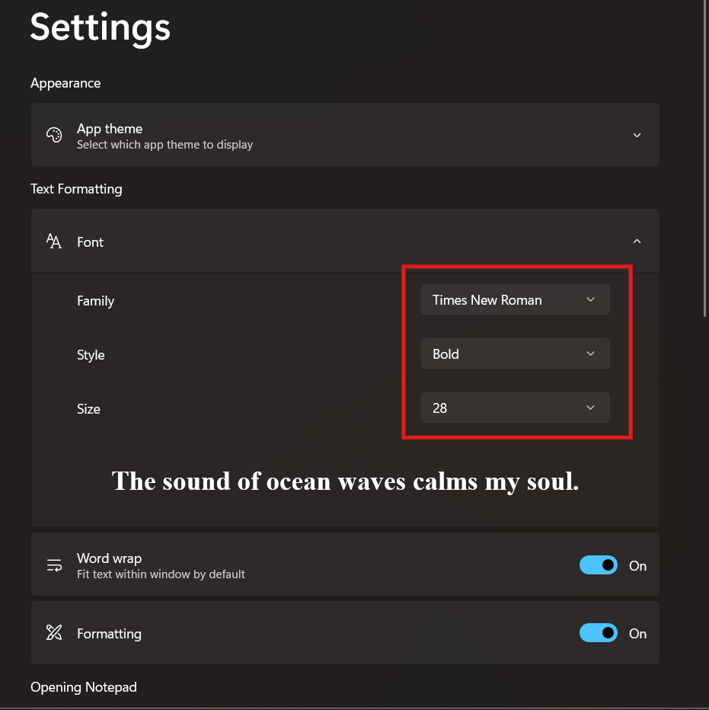 | AE04
10 |  | Click on Back Button | 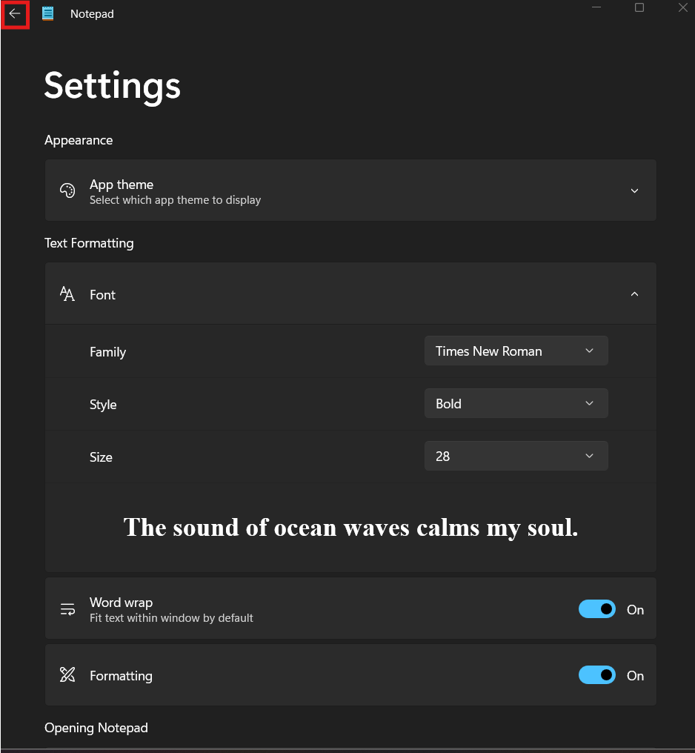
11 | Cases Number,  Died number,  Recovered Number | Write Extracted Data | 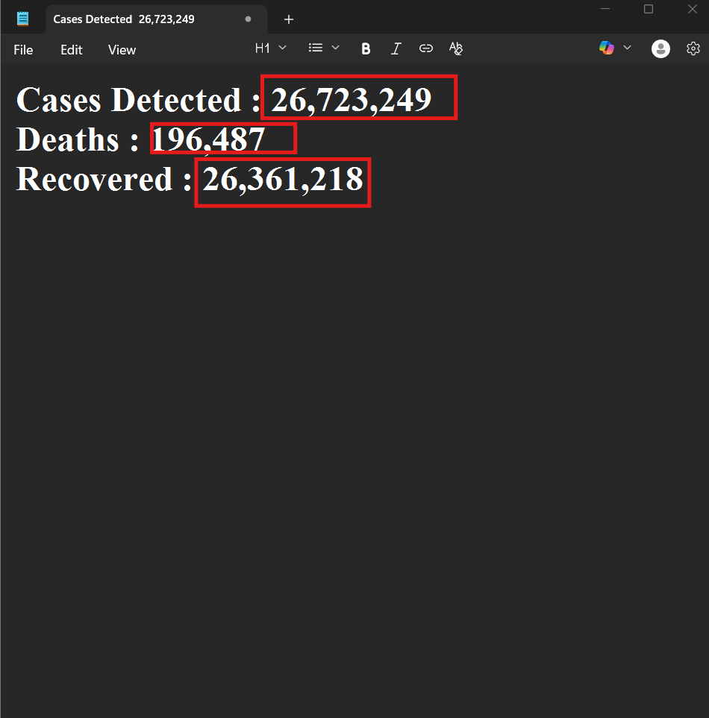
12 |  | click on File in Menu and select Save as | 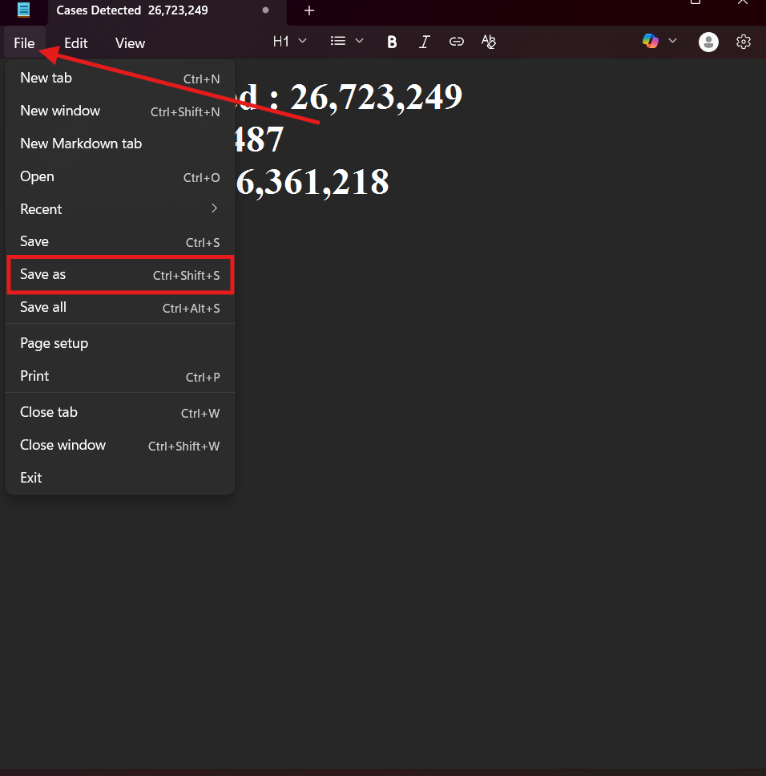 |  | 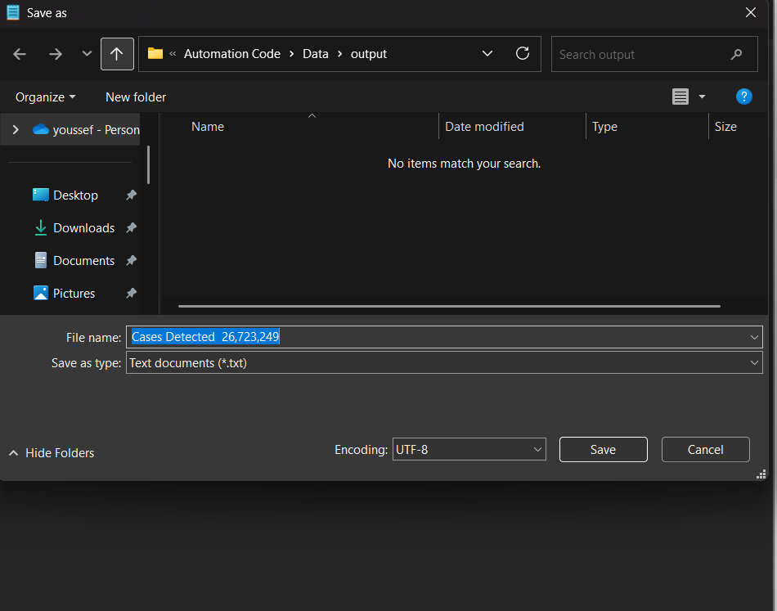
13 | File path | Click Address Bar and write path To Save File | 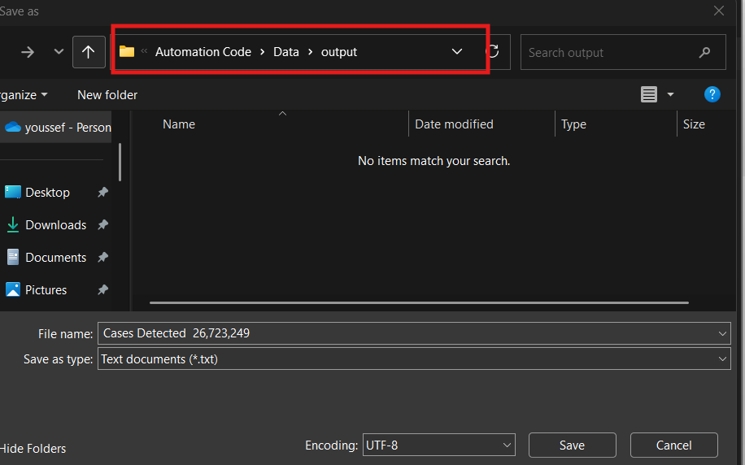 | BE03  Or  AE05 | 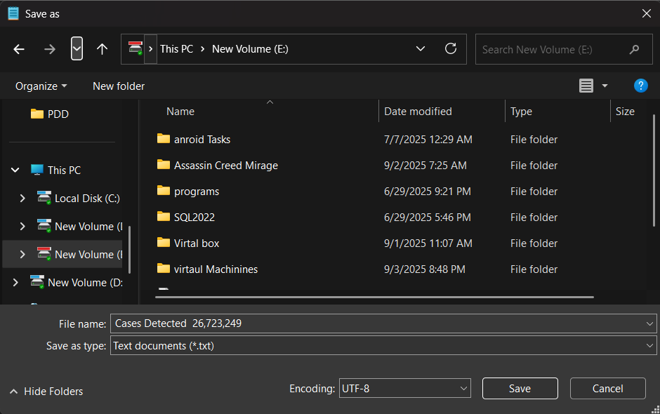
14 | File Name | Click on File name Field and write File Name | 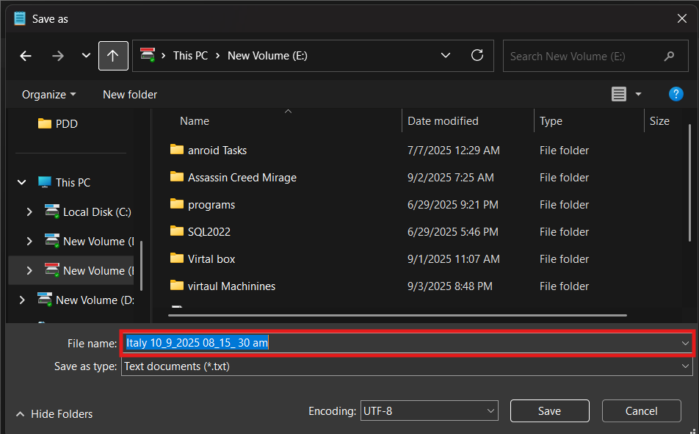 | BE03  Or  AE05
15 |  |  | 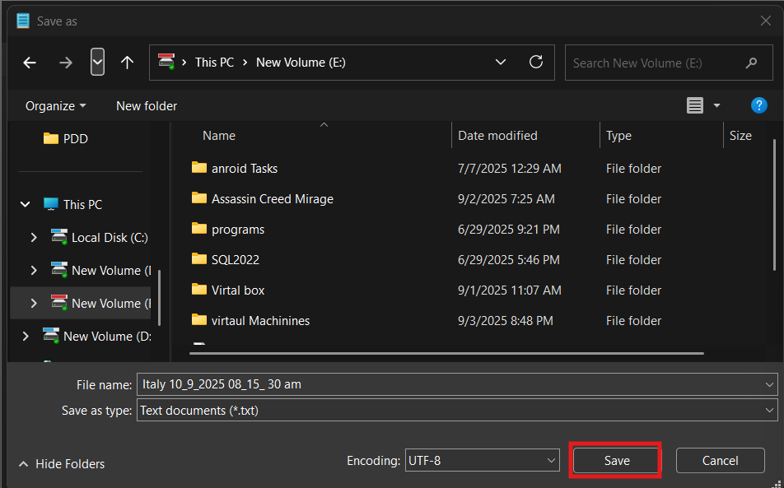
16 |  | Close opened Tap of notepad | 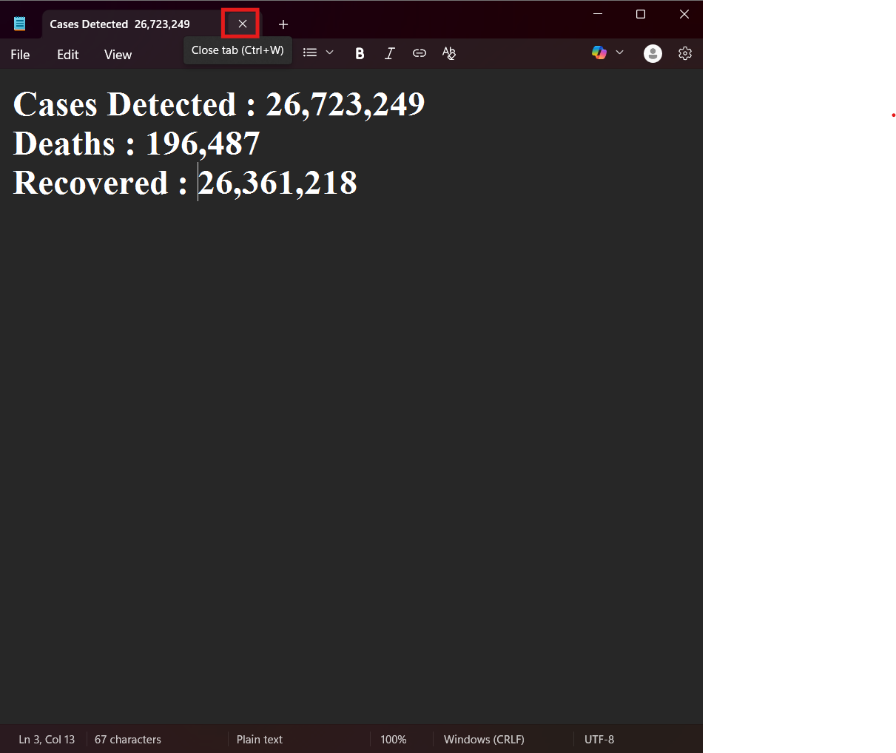

To-be process description
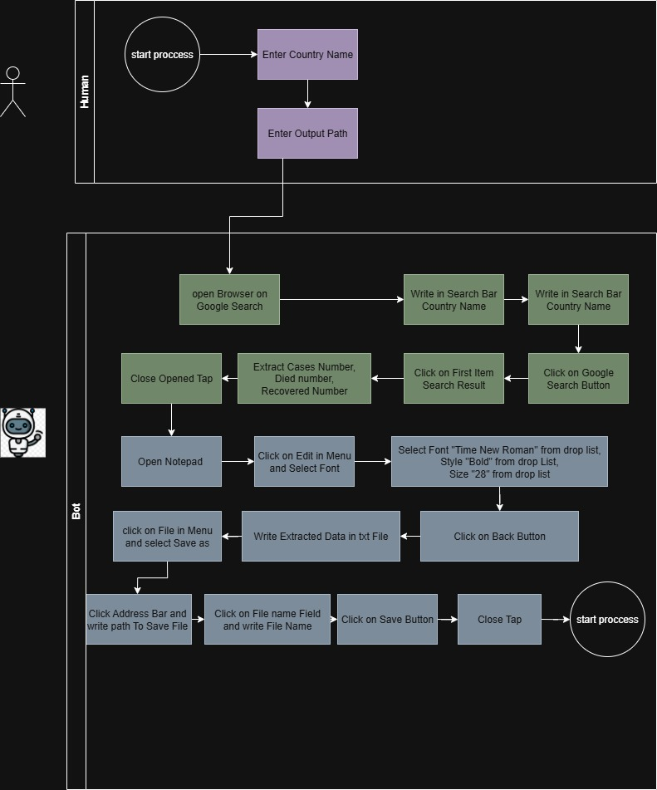

Input/Output data description

The following table should contain details regarding the inputs that every action of the process takes.

# | Sample | Type | Input/Output | Process step # | Storage location
1 | Country Names | File | Input | 2 | Storage
2 | Country Name | string |  | 2 | memory
3 | File Path |  |  | 13
4 | File Name(auto Generated) |  |  | 14
4 | Cases Number |  | input/output | Output:5  Input:11
5 | Died number
6 | Recovered Number
7 | Report File | txt | output | 15 | Storage

Exceptions Handling
The Business Process Owner and Business Analysts are expected to document below all the business exceptions identified in the automation process. Exceptions are of 2 types, and both need to be addressed:
- Known exceptions - previously encountered. A scenario is defined with clear actions and workarounds for each case.
- Unknown exceptions - New situation that was not encountered before. It cannot be predicted and in case it happens it needs to be flagged and communicated to an authorized person for evaluation.

Known business exceptions

# | Exception description | Action to be taken
BE01 | Extracted statistics are incomplete (cases, deaths, or recovered numbers missing) or contain non-numeric characters | Retry extraction up to 3 times; if still incomplete, log error and notify Analytical office
BE02 | Invalid or misspelled country name | Prompt user to re-enter country name; repeated until user give valid Country Name
BE03 | Invalid or misspelled output path | Prompt user to re-enter output path; repeated until user give valid Output Path

Unknown business exceptions
for all other cases which do not follow the rules defined an e-mail should be sent to: rpa_support@raya.it.com with a screen shot and robot should proceed to next transaction .

Applications errors and exceptions handling

Known applications errors and exceptions

# | Exception description | Action to be taken
AE01 | Web browser fails to open Google Search | Retry opening up to 3 times; if still failing, log error and notify IT/ Analytical office
AE02 | coronavirus statics page does not load or times out | Refresh page, retry up to 3 times; if still failing, log issue and escalate to IT
AE03 | Notepad fails to open | Retry opening Notepad up to 3 times; if still failing, log error and notify IT support
AE04 | Dropdown menus (Font, Style, Font Size) fail to populate or become unresponsive | Close Notepad and open it again, retry 3 times; if issue persists, log as UI failure and escalate to IT
AE05 | Error occurs while saving file (invalid path, access denied, or file name issue) | Prompt user for correct file path/name; if issue persists, log error and notify IT support

Unknown applications errors and exceptions
.robot should attempt to access the application 3 times then it should terminate process and escalate to Project Manager and Director of Accounting and IT Team.

Reporting
In this section all the reporting requirements of the business should be detailed so that when the automation solution is moved to production the administrators can track the performance of the solution.

Report Type | Update frequency | Details | Monitoring Tool to visualize the data
Error & Exception Report | Real-time / Daily | Captures invalid inputs, generator downtime, or failed file saving attempts | Orchestrator Dashboard / Error Log File
Txt file | After each run | Statics Data are stored | Orchestrator Dashboard / Bot Logs

In scope for automation
All process Steps are in scope of Automation.

Out of scope for automation
All process Steps are in scope of Automation .

Change/Improvement details
Use this section to detail the list the change or improvement opportunity in the To-Be Process.
Important aspects to be mentioned: what is the initiative, expected outcome, expected completion date, contact person for details, and if will impact the current automation request.

# | Initiative Name | Process Action(s) where it is identified | Impact on current Automation Request | Expected Completion Date | Contact Person

Other

Additional sources of process documentation
Item | Location
Video Recording of the process (Optional)
Business Rules Library (Optional)
Other documentation (Optional)
Standard Operating Procedure(s) (Optional)
High Level Process Map (Optional)
Detailed level process map (Optional)
Work Instructions (Optional)
Input Files (Optional)
Output Files (Optional)

Change requests
# | Date | Change description | Affected process steps / section | Change reason | Change initiator

Document approval

